# 

# **Department of Computer Science and Engineering Islamic University of Technology (IUT)** A subsidiary organ of OIC

# **Lab Report 04**

# CSE 4512: Computer Networks Lab

## 

## **Name:­­ Rashikh­ Ahmad Student ID: 210041255 Section: 2(A) Semester: 5th Academic Year: 2023-2024**

**Date of Submission: 07/10/24**

### **Title:** VLAN configuration and Inter-VLAN routing.

### **Objective**:

### Define and describe the concept of VLAN

### Describe the advantages of VLAN

### Design and implement VLAN and inter-VLAN routing

### Task-1 - Part 1: Configure Layer 3 Switching Part 2: Configure Vlan Part 3: Configure Inter-Vlan Routing

### Task-2 - Part 1: Build the Network and Configure Basic Device Settings Part 2: Create VLANs and Assign Switch Ports Part 3: Configure an 802.1Q Trunk between the Switches Part 4: Configure Inter-VLAN Routing on the Router Part 5: Verify Inter-VLAN Routing is working

### **Devices/ Software Used**:

* + - 1. Cisco Packet Tracer

**Theory:**

**VLAN Definition:** VLAN or Virtual LAN (Local Area Network) is a logical grouping of networking devices. When we create VLAN, we actually break a large broadcast domain into smaller broadcast domains. Consider VLAN as a subnet. Just as two different subnets cannot communicate with each other without a router, different VLANs also require a router to communicate.

**Usage of VLAN:**

*(Explain the usage of VLAN with an example)*

Consider a company with three departments: HR, Sales, and IT. Without VLANs, all devices in the network would receive broadcast traffic from any department, leading to unnecessary congestion. However, by implementing VLANs:

HR could be placed in VLAN 10.  
Sales could be placed in VLAN 20.  
IT could be placed in VLAN 30.  
This would ensure that broadcast traffic from the HR VLAN (VLAN 10) stays isolated from Sales (VLAN 20) and IT (VLAN 30), reducing unnecessary traffic.

**Inter VLAN Routing:**

*(Explain the procedure of routing a packet within different VLANs)*

Inter-VLAN routing is the ability to route, or send, traffic between VLANs that are normally blocked by default.  
Switches and VLANs work at the MAC address Layer (Layer 2). Traffic can’t be routed between VLANs at Layer 2 based on MAC addresses. Therefore, routers (or Layer 3 switches) that use IP addresses (Layer 3) are required for inter-VLAN routing.

**Router-on-a-stick:**

In this approach, a single physical router interface is configured as a trunk and is used to route traffic between different VLANs. Subinterfaces are created on this trunk interface, each corresponding to a VLAN.  
**Layer 3 Switch:**

Modern switches often have Layer 3 routing capabilities. In this method, routing is done on the switch itself using SVIs (Switch Virtual Interfaces). SVIs are virtual interfaces that are assigned to VLANs, and they allow the switch to route traffic internally between VLANs without the need for an external router.

### **Diagram of the experiment:**

*(Provide screenshot(s) of the final network topology. Make sure to label the network components.)*

**Task #01:**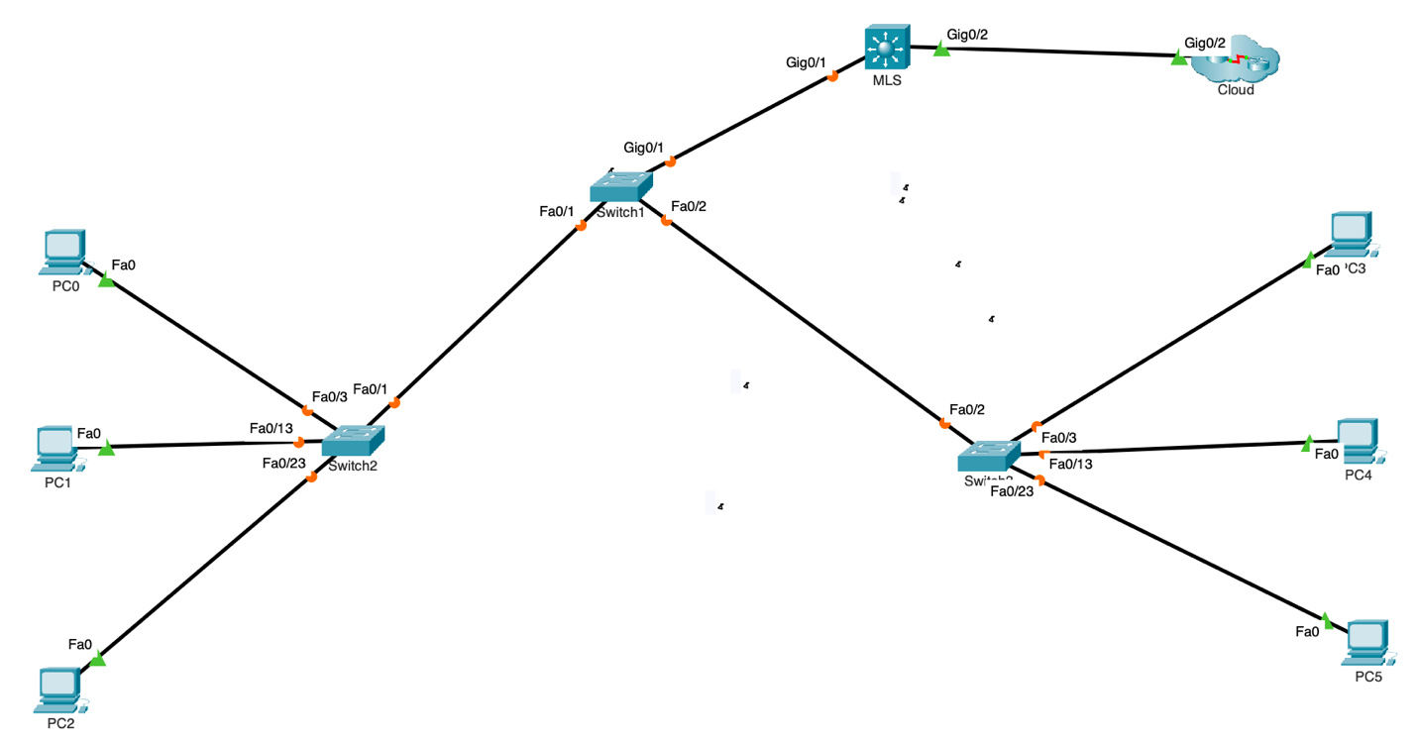

**Task #02:**

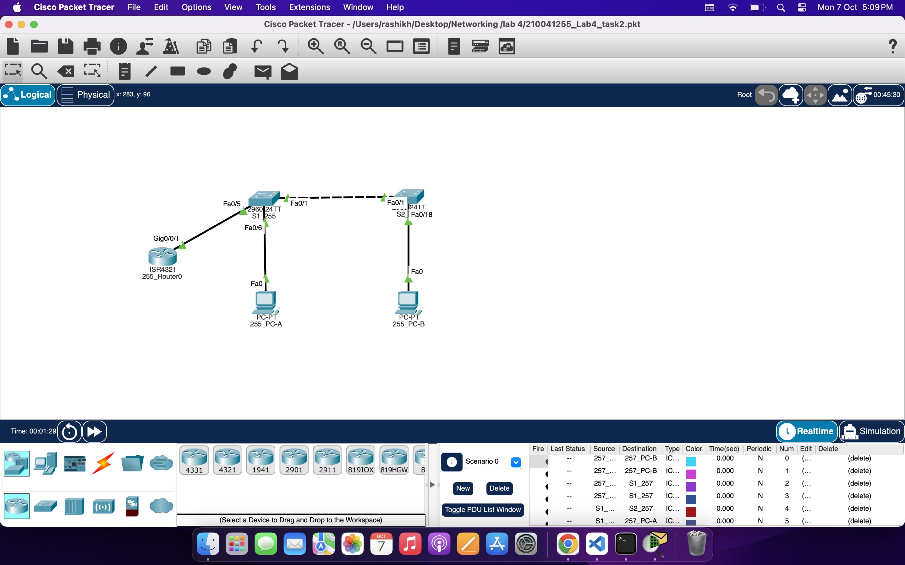

### 

### **Working Procedure:**

***(****Explain in brief how you completed the tasks. Provide necessary screenshots of the commands used for each task.)*

**TASK #01:**

**1. Configuring g0/2 with ip. Save running configuration as startup configuration. Then ping.**

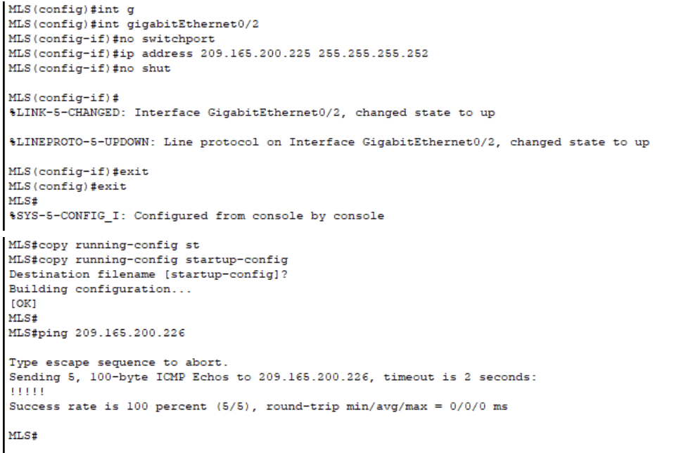

1. **Add VLans to MLS.**

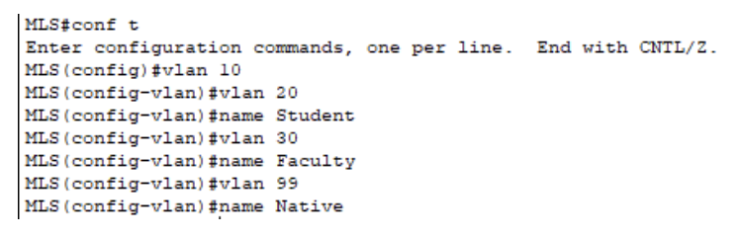

1. **Configure SVI on MLS.**

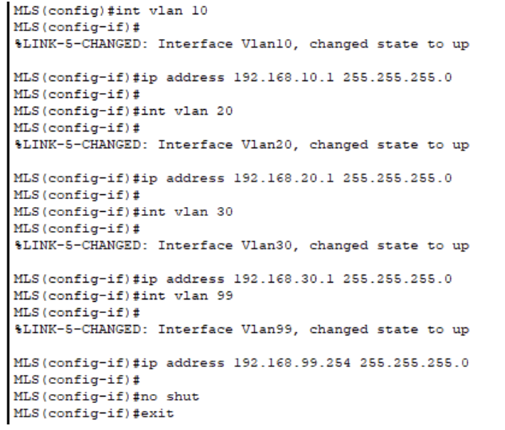

1. **Add VLans to Switches.**

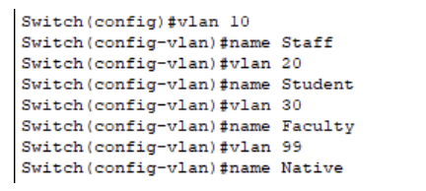

1. **Configure Trunking on MLS.**

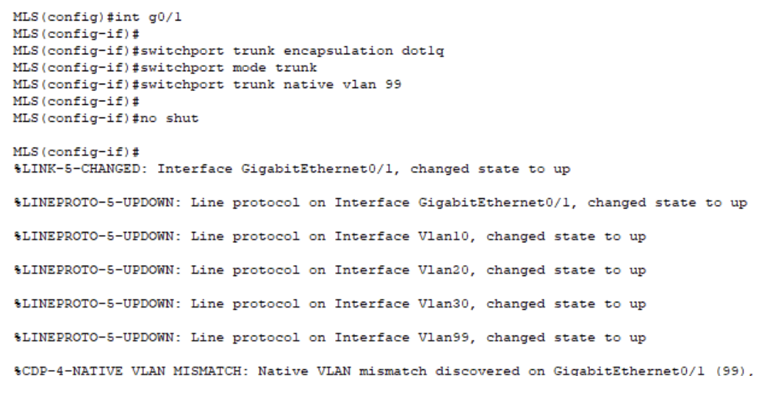

1. **Configure trunking on Switches**

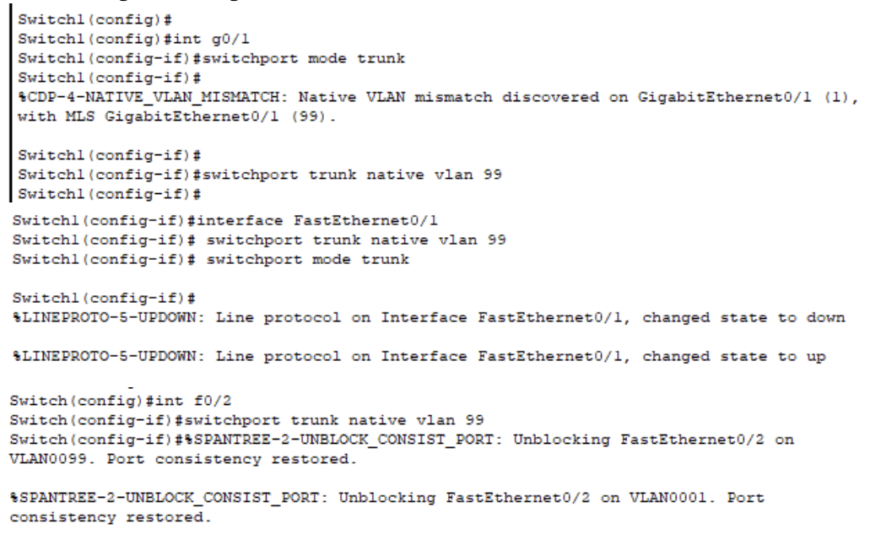

**After all configuration,**

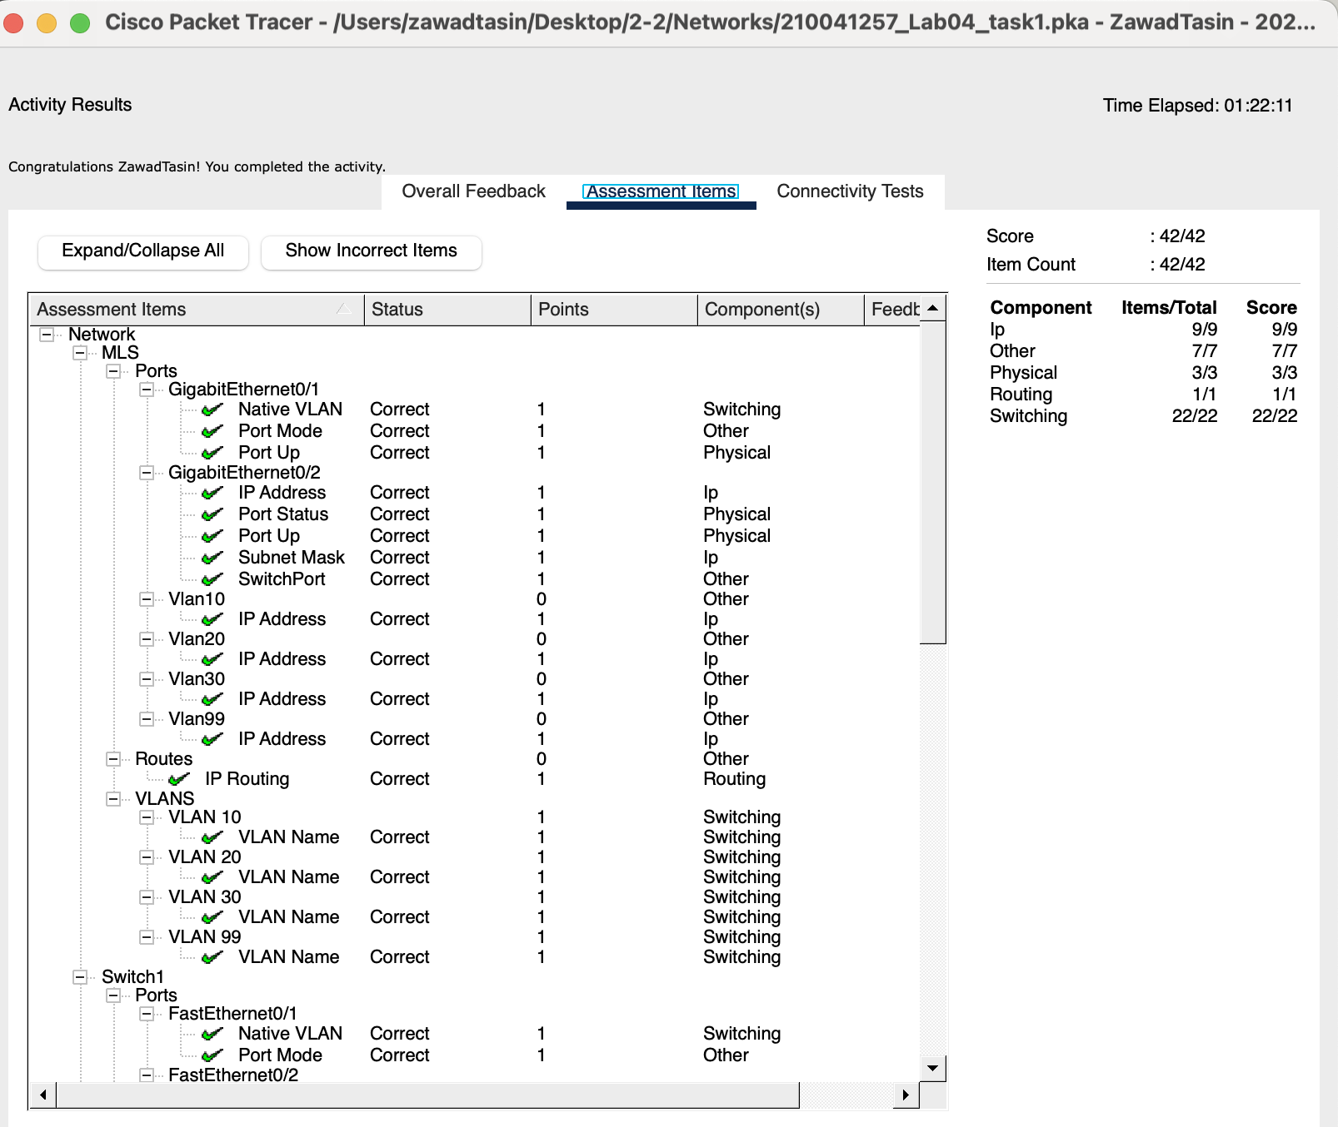

**TASK #02:**

* + - 1. **Configure basic settings for the router and Switches.**

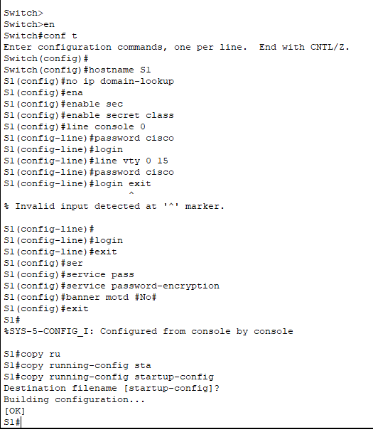

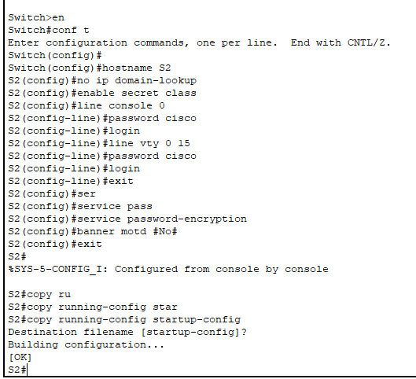

**2. Configure PC hosts.**

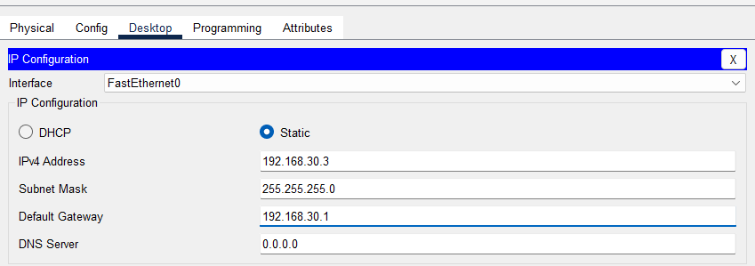

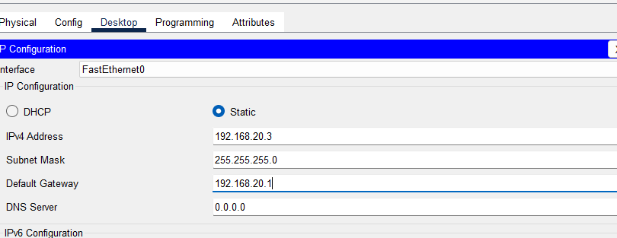

**3. Create VLANs and Assign Switch Ports.**

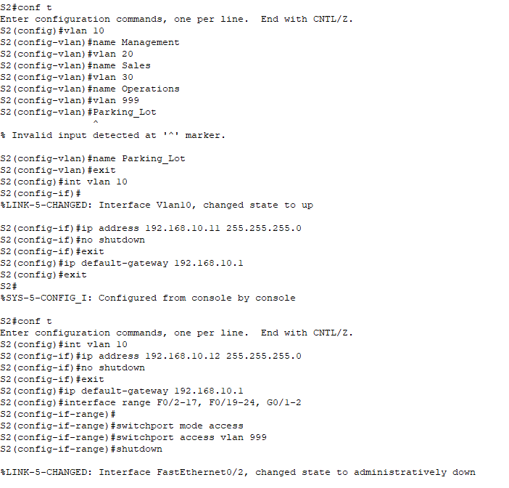

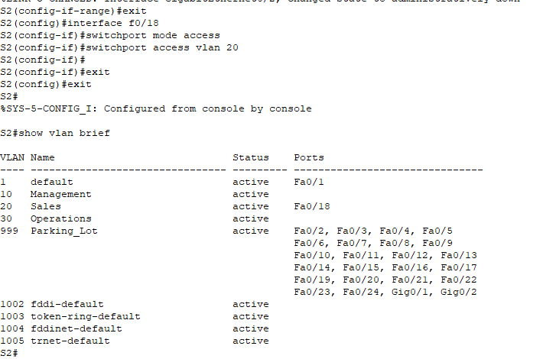

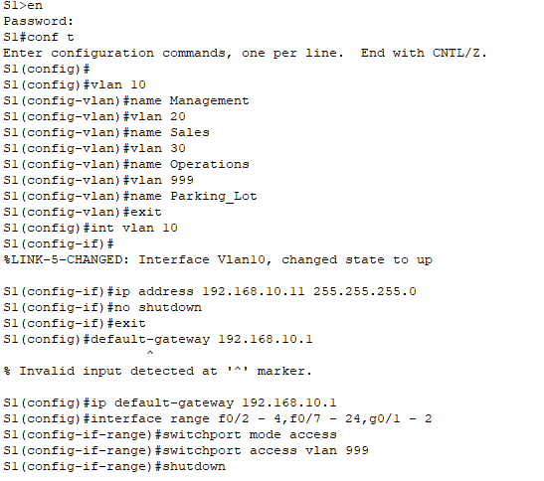



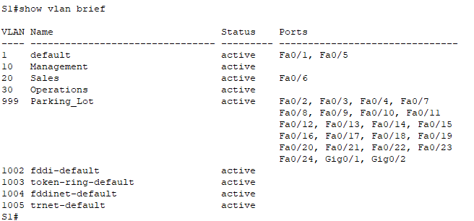

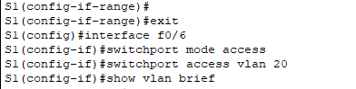

**4. Configure an 802.1Q Trunk Between the Switches**

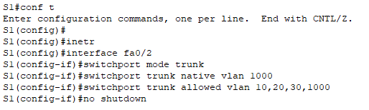

**5. Configure Inter-VLAN Routing on the Router Configure the router.**

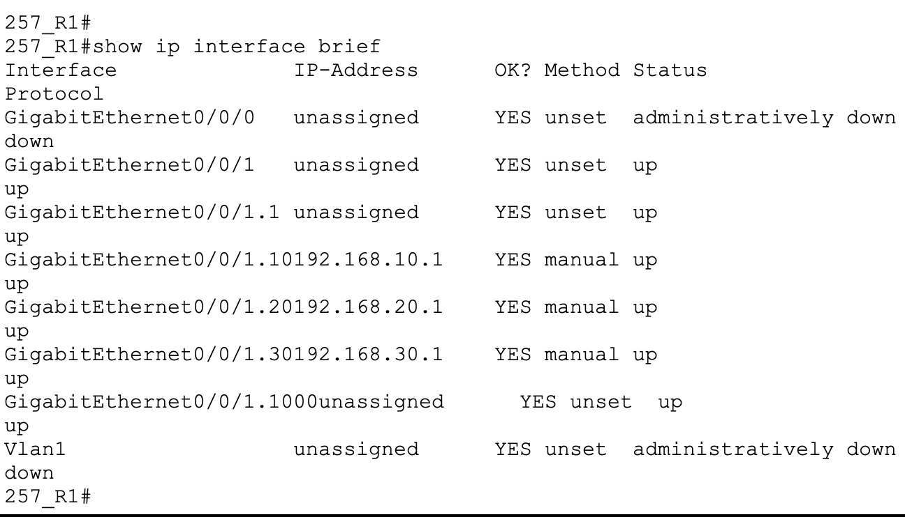

**6. Complete the following tests from PC-A. All are successful.**

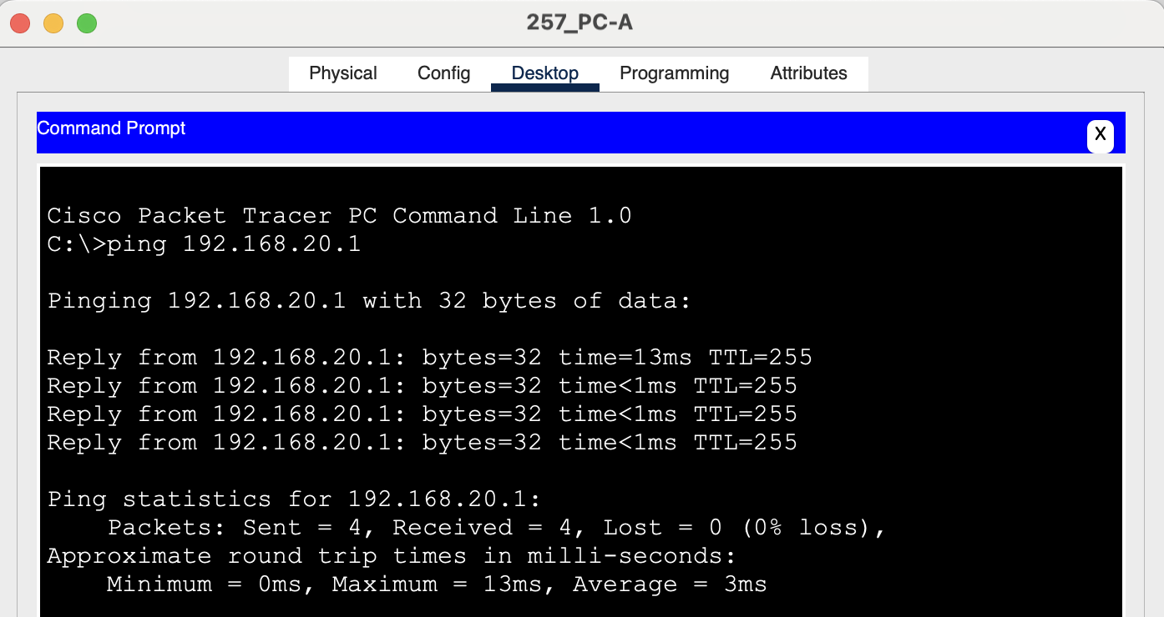

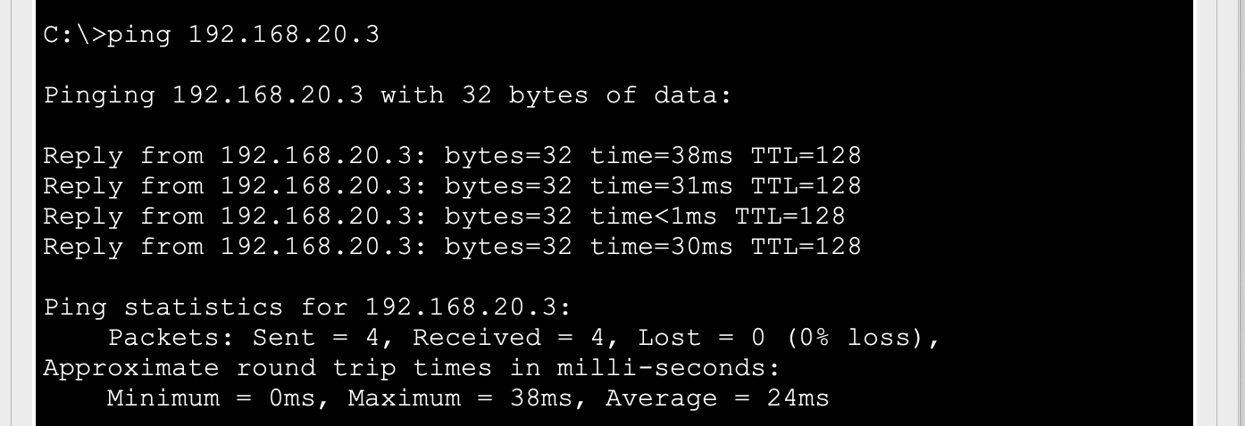

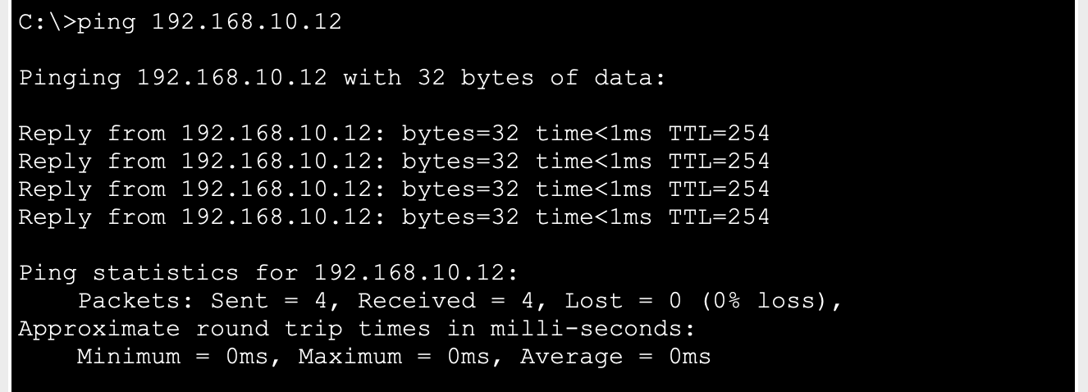

**7. tracert command in 218_PC-B.**

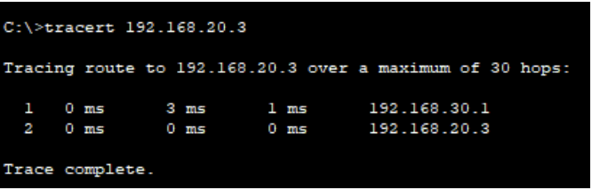

### **Observation**:

*(Your observation with the screenshots of* ***show vlan*** *command in switches)*

### **Challenges (if any):**

### 